AAT LAB 8

Name : Swarangi Kothawade
Div/Roll No. : A-34

N-Queens Problem
#include <iostream>
using namespace std;

int board[10][10], N;

// Checks if it's safe to place a queen at board[row][col]
bool isSafe(int r, int c) {
for (int i = 0; i < c; i++) if (board[r][i]) return false; // Left Row
for (int i = r, j = c; i >= 0 && j >= 0; i--, j--) if (board[i][j]) return false; // Upper Left Diag
for (int i = r, j = c; i < N && j >= 0; i++, j--) if (board[i][j]) return false; // Lower Left Diag
return true;
}

bool solve(int col) {
if (col >= N) return true; // All queens placed successfully

for (int i = 0; i < N; i++) {
if (isSafe(i, col)) {
board[i][col] = 1; // Place queen
if (solve(col + 1)) return true; // Move to next column
board[i][col] = 0; // Backtrack: Remove queen and try next row
}
}
return false;
}

int main() {
cout << "Enter number of queens: ";
cin >> N;

if (solve(0)) {
for (int i = 0; i < N; i++) {
for (int j = 0; j < N; j++)
cout << (board[i][j] ? "Q " : ". ");
cout << endl;
}
} else cout << "No solution exists";

return 0;
}

OUTPUT
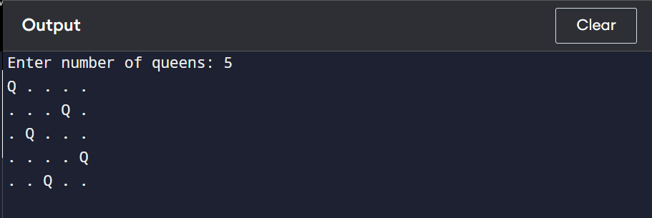

Graph Coloring Problem
#include <iostream>
using namespace std;

int graph[10][10], color[10], n, m;

// Check if it's safe to color vertex 'v' with color 'c'
bool isSafe(int v, int c) {
for (int i = 0; i < n; i++)
// If there's an edge AND the neighbor has the same color
if (graph[v][i] && color[i] == c)
return false;
return true;
}

bool solve(int v) {
if (v == n) return true; // All vertices are colored

for (int c = 1; c <= m; c++) { // Try colors 1 to m
if (isSafe(v, c)) {
color[v] = c;
if (solve(v + 1)) return true;
color[v] = 0; // Backtrack
}
}
return false;
}

int main() {
cout << "Vertices: "; cin >> n;
cout << "Adjacency Matrix (0/1):\n";
for (int i = 0; i < n; i++)
for (int j = 0; j < n; j++)
cin >> graph[i][j];

cout << "Max Colors: "; cin >> m;

if (solve(0)) {
for (int i = 0; i < n; i++)
cout << "Vertex " << i << " -> Color " << color[i] << endl;
} else cout << "No solution";

return 0;
}

OUTPUT
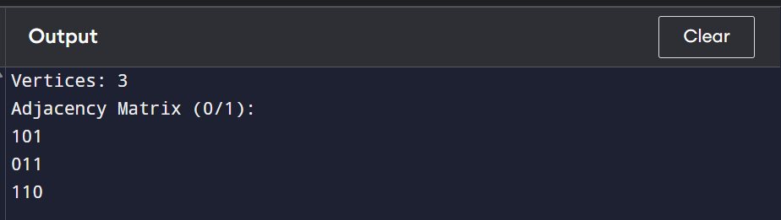

Hamiltonian Cycle
#include <iostream>
using namespace std;

int graph[10][10], path[10], n;

// Check if adding vertex 'v' at current 'pos' is valid
bool isSafe(int v, int pos) {
// Check if there is an edge from the previous vertex in the path to 'v'
if (!graph[path[pos - 1]][v]) return false;

// Check if 'v' has already been included in the path
for (int i = 0; i < pos; i++)
if (path[i] == v) return false;

return true;
}

bool solve(int pos) {
if (pos == n) {
// Return true if there is an edge from the last vertex back to the first
return graph[path[pos - 1]][path[0]];
}

for (int v = 1; v < n; v++) { // Try different vertices (starting from 1)
if (isSafe(v, pos)) {
path[pos] = v;
if (solve(pos + 1)) return true;
path[pos] = -1; // Backtrack
}
}
return false;
}

int main() {
cout << "Vertices: "; cin >> n;
cout << "Adjacency Matrix (0/1):\n";
for (int i = 0; i < n; i++)
for (int j = 0; j < n; j++)
cin >> graph[i][j];

for (int i = 0; i < n; i++) path[i] = -1;
path[0] = 0; // Start at vertex 0

if (solve(1)) {
cout << "Cycle: ";
for (int i = 0; i < n; i++) cout << path[i] << " -> ";
cout << path[0] << endl;
} else cout << "No cycle exists";

return 0;
}

OUTPUT
